**Graduation Speech, 2021 Commencement (MScPACG Session)**

*LEUNG Chak Yan Frankie, MScPACG (CG Stream), Cohort 2019*

To celebrate this significant milestone of the MScPACG students, the Department of Accountancy invited one of the graduates, Frankie, to give a speech. Although the Commencement was held in hybrid mode (face-to-face and virtual), everyone enjoyed it and found it very memorable.

*** ** *** ** ***

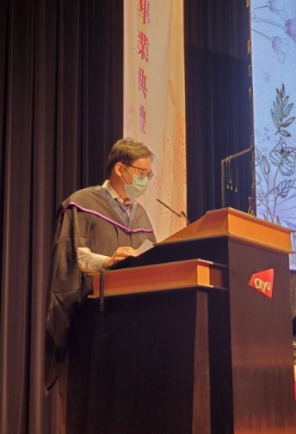

Dear Department Head, professors, fellow graduates, family, and friends:

Greetings. It is my honor to stand here and give a speech on behalf of my fellow graduates today.

My name is Frankie. I am graduating from the Corporate Governance Stream (CG) of the Master of Science in Professional Accountancy and Corporate Governance Programme at the Department of Accountancy. I joined this programme two years ago in 2019.

I want to begin my speech by congratulating my fellow graduates on achieving this milestone. Two years ago, when we received the admission offer, all of us must have imagined how proud we would be on this day.

But back then, we had never imagined the challenge and difficulty we were about to experience during the next two years. During the two years of study, we have experienced social unrest and a global pandemic. We had to adapt to online learning, which is a totally different learning style. We did not have face-to-face interactions with our professors and classmates. We did not know if we could focus and if we could learn effectively. We were not able to enjoy campus facilities during most of our study period. Many of our activities, such as study tours and alumni connections, were cancelled. However, we did not let those challenges and losses defeat us. We adapted to the critical circumstances; persevered with our work, life, and study; and stayed strong mentally and physically.

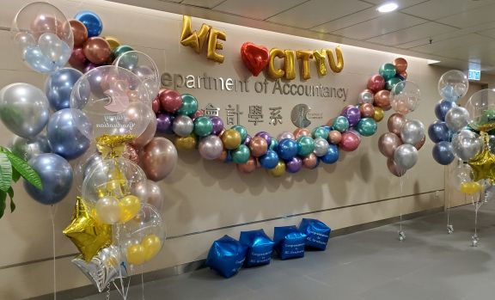So here we are today, gathered to celebrate our accomplishment. I would like to thank those who supported us through this exhausting but rewarding journey: our family who are always there when support is needed; our professors who have tried their best to adapt to the new form of teaching and deliver their knowledge effectively; and all of the staff from CityU and the department who have continued to work efficiently during the turmoil and uncertainty. I also want to thank all of my teammates for their hard work. We have finished so many projects, presentations, and assignments together across all of the subjects. Without your help and collaboration, my two years of studies would not have been so smooth and fun.

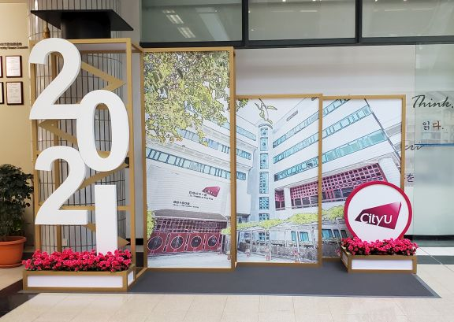We are privileged to live in a developed economy. We have enough masks and sanitizers in the shops everywhere. We have well-equipped hospital facilities and well-trained medical doctors and nurses to take care of those who are infected. We have free access to vaccine shots. Therefore, we can gather here today to celebrate our graduation without worrying too much about our safety. However, in some less developed regions of the world, people are struggling to make ends meet and waiting desperately for proper treatments and vaccines. Every one of us now holds a Master’s degree and has gained valuable knowledge and developed our critical thinking ability while studying for the degree. I believe there is a bright future waiting for us, no matter if we stay with our current employer or seek opportunities elsewhere. However, what about those people who are suffering in the other parts of the world or even in our local society. Let us also think about what we can do for the unprivileged and to change the divided world, while trying to make a better life for ourselves. Let each of us take a small step toward that big goal.

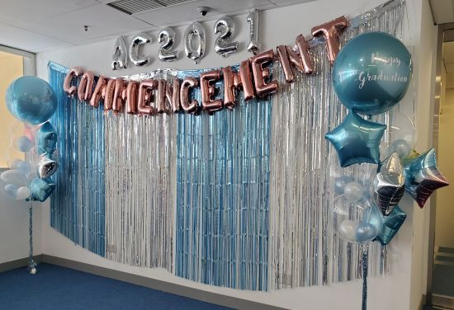Congratulations again to all of us on our graduation. Thank you, my classmates, professors, family, and friends for helping me go through this challenging yet remarkable and unforgettable two-year experience. This is not the end. It is the beginning of a new journey. The courage and wisdom we have gained from our past experiences will guide us on this new journey.

Please keep in touch, and I wish the best to you all. Thank you.